Excel Assignment - 6

1. What are the various elements of the Excel interface? Describe how they're used.

|  |  |
| --- | --- |
| **Interface Element** | **Description** |
| Ribbon Tabs | Ribbon Tab is a tab that organizes commands by topic |
| The Ribbon | Commands underneath the Tabs |
| Ribbon Groups | Grouping of related commands |
| Dialog Box Launcher | Opens a dialog box that includes additional commands |
| Quick Access Toolbar | One click access to any frequently used command |
| Name Box | Displays cell location and can be used to navigate to a cell location |
| Select All Button | Selects all the cells in a worksheet |
| Formula Bar | View, enter, or edit cell contents |
| Insert Function Button | Displays Insert Function dialog box |
| Scroll Bars | Used to navigate up, down, left & right |
| Zoom Slider | Zoom into an area of the worksheet |
| View Buttons | Switch between Normal, Page Layout and Page Break Preview views |
| Worksheet tabs | Tabs used to select individual worksheets |
| The Workspace | The area inside of the columns and rows used in Excel |
| Columns | Columns use letters |
| Rows | Rows use numbers |

2. Write down the various applications of Excel in the industry.

Answer:

budgeting, analysis, forecasting, spotting trends, reporting, and more.

3. On the ribbon, make a new tab. Add some different groups, insert commands in the groups and name them according to their commands added. Copy and paste the screenshot of the steps you followed.

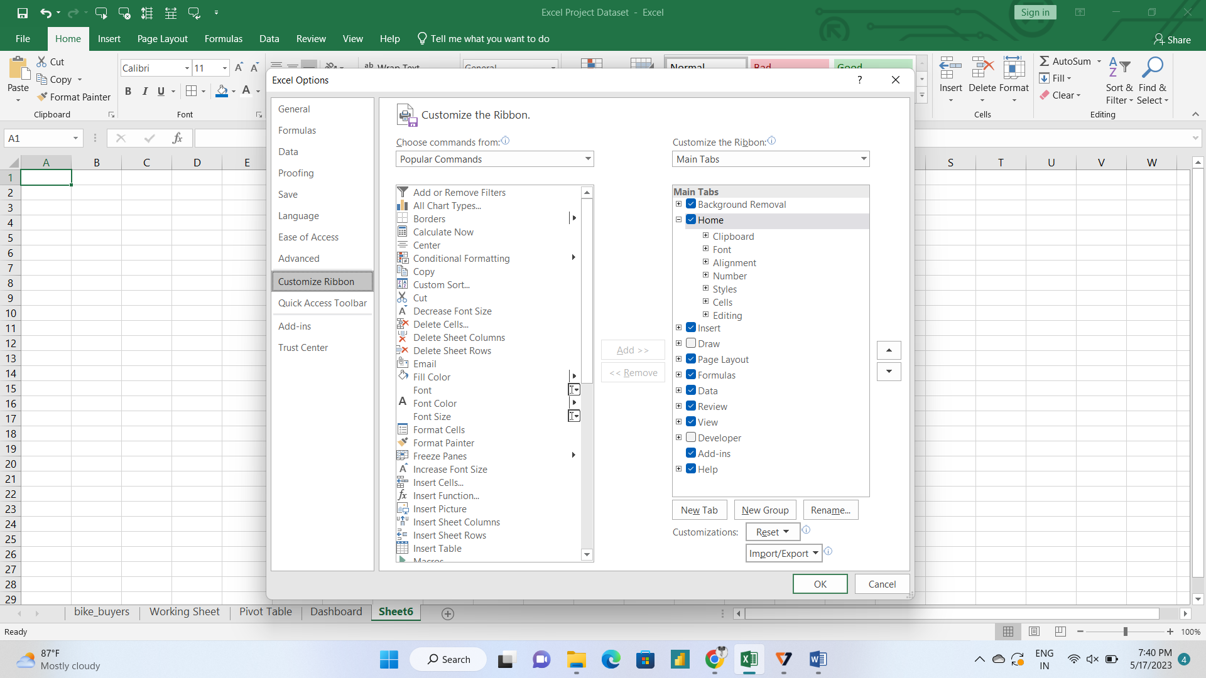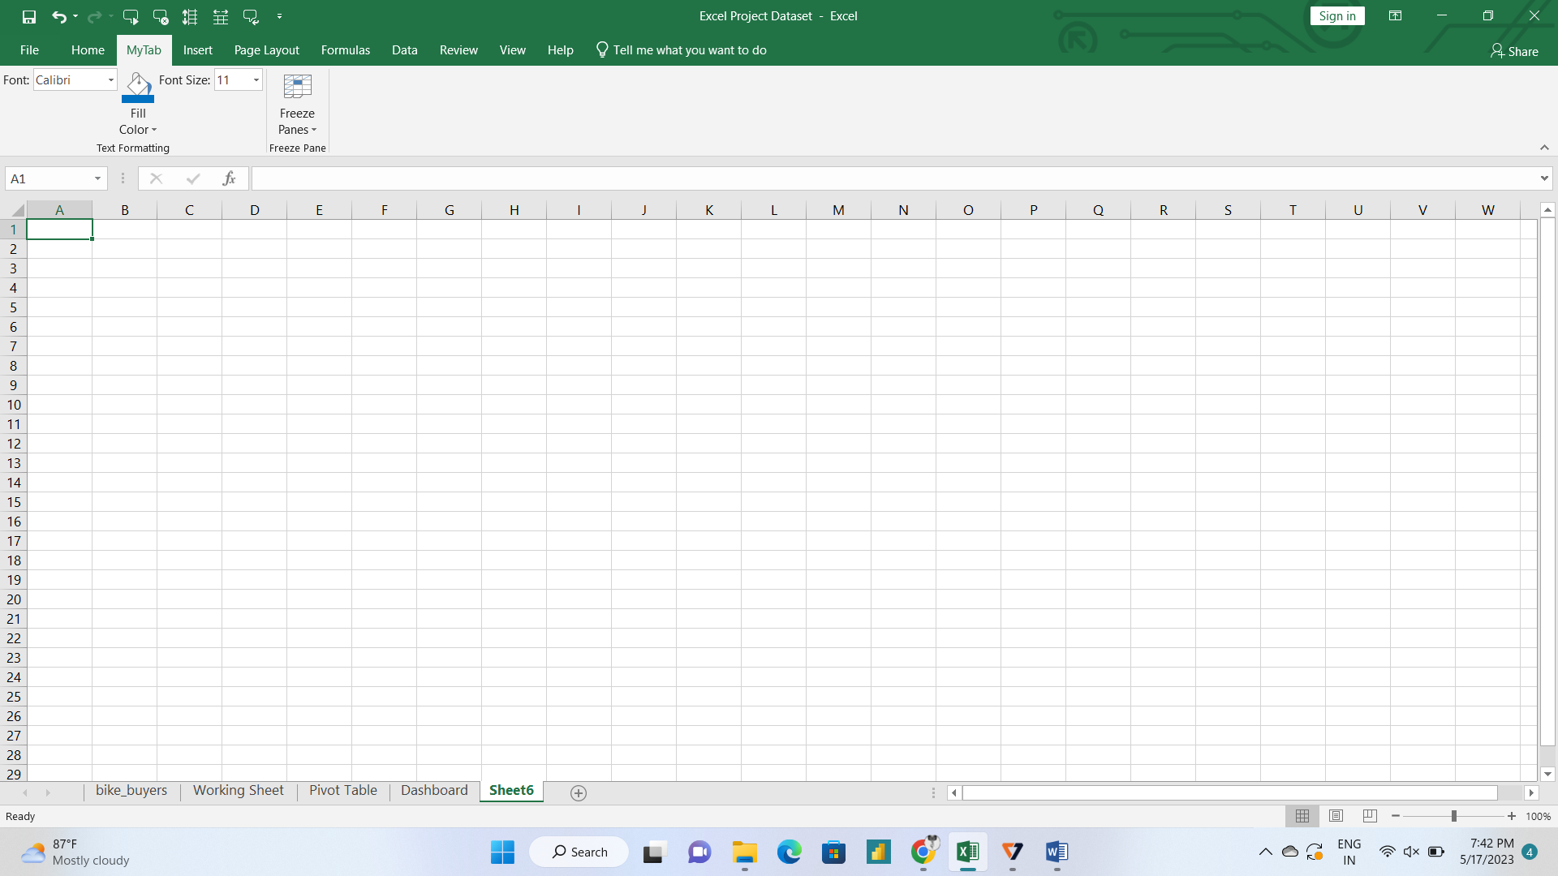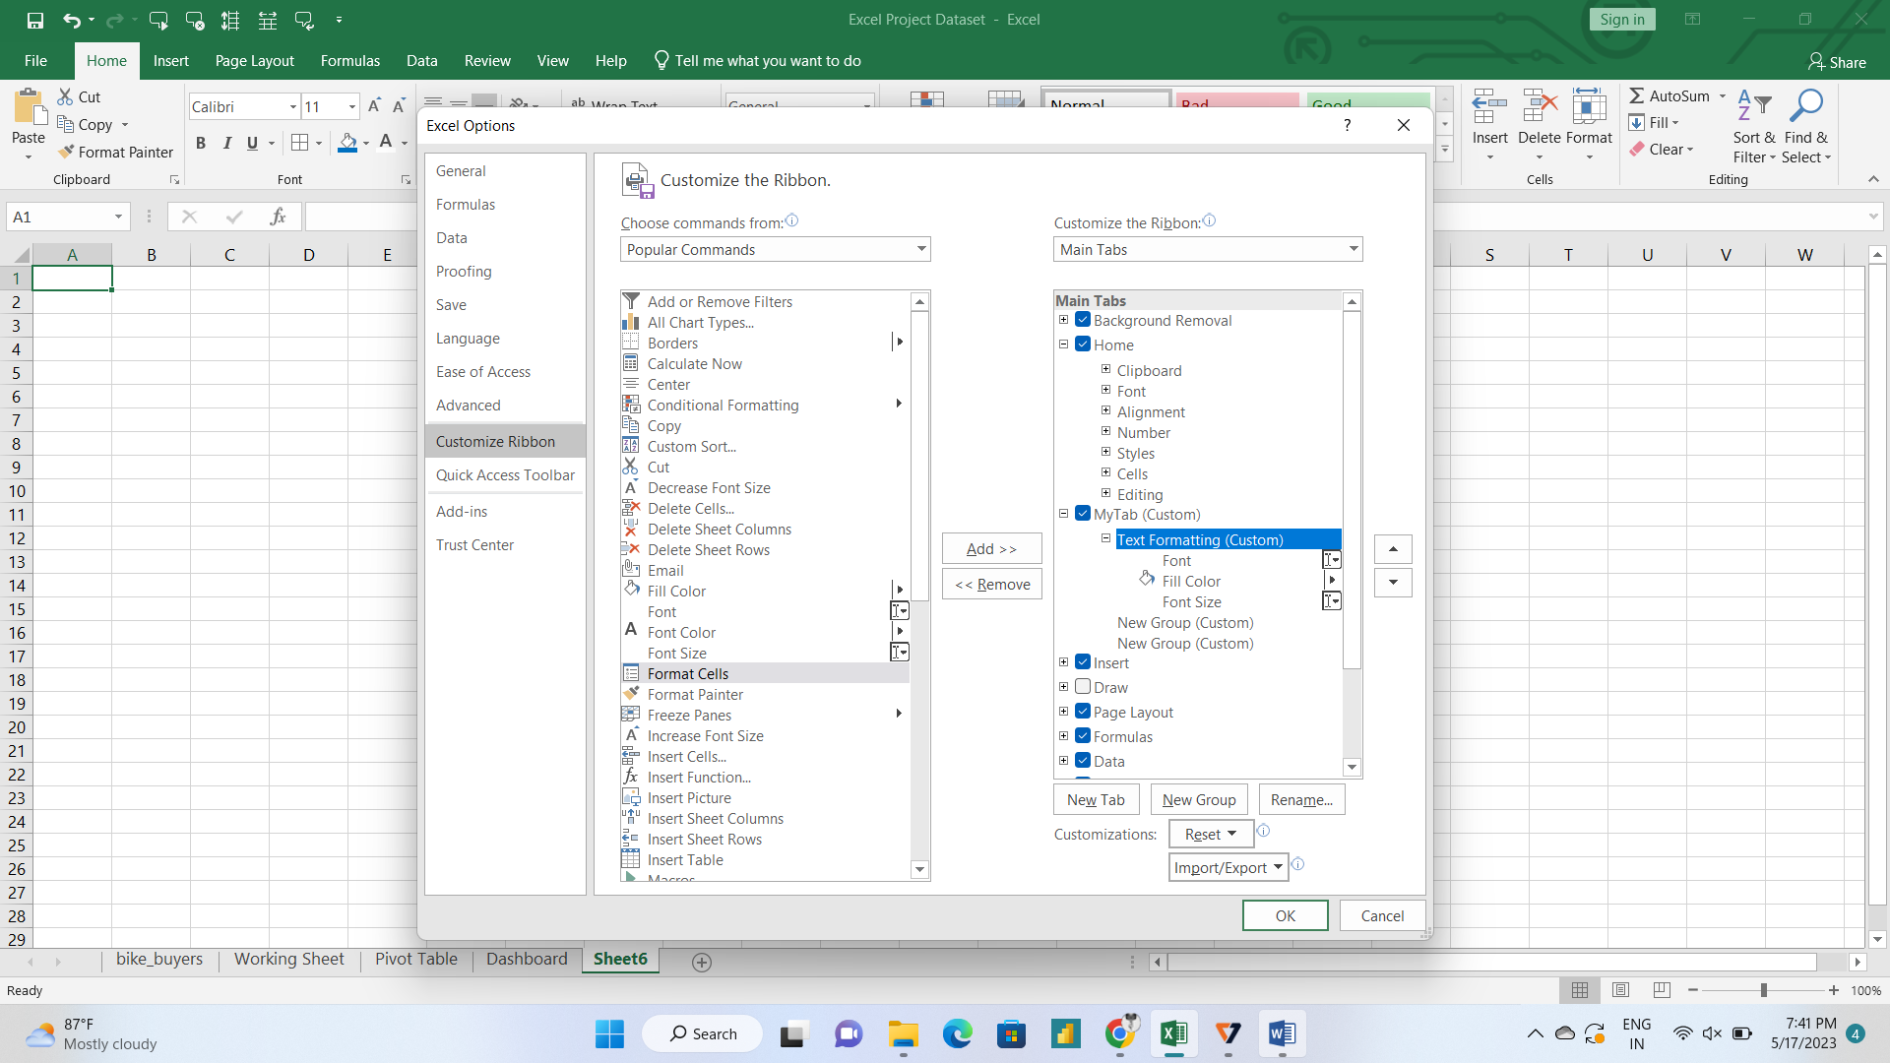

4. Make a list of different shortcut keys that are only connected to formatting with their functions.

Answer:

**Windows keyboard shortcuts**

* Copy: Ctrl + C.
* Cut: Ctrl + X.
* Paste: Ctrl + V.
* Maximize Window: F11 or Windows logo key + Up arrow.
* Open Task View: Windows logo key + Tab.
* Display and hide the desktop: Windows logo key + D.
* Switch between open apps: Alt + Tab.
* Open the Quick Link menu: Windows logo key + X.

5. What distinguishes Excel from other analytical tools?

Answer:

One of the reasons Excel is so popular is because it is jam-packed with features and functions that can be used to clean, aggregate, pivot, and graph data

6. Create a table and add a custom header and footer to your table.

